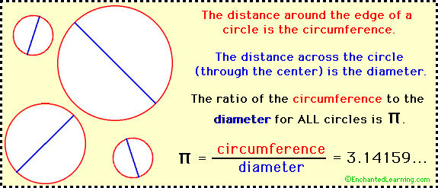
What is Pi?
Pi (π) is a number that is roughly equal to 3.14159. Pi is the ratio of the circumference (perimeter) of any sized circle to its diameter. No matter what sized circle you have, the ratio of its circumference to its diameter is always the same -- pi. For example, when a circle's diameter is 1, its circumference is π. When a circle's diameter is 2, its circumference is 2 times π.
Pi is Irrational
Pi is an irrational number. This means that pi cannot be written as a fraction of two whole numbers and that the decimal digits of pi continue infinitely without any repeating pattern. Pi is roughly 3.14159265358979323846.... Using computers, pi has been calculated to many million of digits past the decimal point. For many purposes, using the approximation 3.1416 is sufficient. Good approximations for pi are 22/7 and 355/113.
Formulas
Pi is used in many calculations, including finding the circumference and area of a circle, and the volume and surface area of a sphere, cone, and cylinder. Pi is also used in geometry, probability and statistics, and many other fields.
 | Circumference | Area
Circle  (radius = r) (diameter = d) | 2π r  π d | π r²

Centers:
Center 1: Circumference with Diameter!!!!
Find the Circumference of Circle A, B, and C using the diameters of the circles.
Measure the diameter in WHOLE centimeters!!!
Example: C = π d If the diameter is 7 cm, then do C = π x 7 or C = 3.14 x 7, so C= 21.98 cm
Circle A: C = π d Show ALL WORK!
C =______________________

Circle B: C = π d
C = _____________________

Circle C: C = π d
C = _______________________
Center 2: Circumference with Radius!!
Find the Circumference of Circle A, B, and C using the radius of the circles (in WHOLE centimeters).
Example: C = 2 π r If the radius is 4 cm, then do C = 2 x π x 4 or C = 2 x 3.14 x 4, so
C= 25.12 cm
Circle A: C = 2 π r Show ALL WORK!
C = _______________________

Circle B: C = 2 π r
C = _______________________

Circle C: C = 2 π r
C = _______________________
Center 3: The PIE TABLE!!!
Choose one of each kind of pie you like. Go back to your table and measure the radius of your favorite type (in centimeters). Be careful not to get pie on your ruler. Find the Circumference of your pie following the steps in Center 2. After finding it’s circumference, EAT YOUR PIE!!
My Favorite Pie (available): _____________________ It’s radius: _______________
Circumference = _____________________________________

Center 4: Cutie “Pi” Bracelets
Use the beads to make a bracelet to model the first 7 digits of pi (in order, with the decimal included) following the code below.
3.141592
1 = pink 3 = green decimal point = choose your color
4 = blue 9=yellow 2=white 5= red

Center 5: Pi Coloring
Color and Cut out the Pi symbol, glue to a piece of construction paper and put your name and number on it.

Center 6: Cutting Pi (read carefully)
Materials
circular object
string
scissors
To Do and Notice
Choose 1 circle. Carefully wrap string around the circumference of your circular object. Cut the string when it is exactly the same length as the circumference. Now take your “string circumference” and stretch it across the diameter of your circular object. Cut as many “string diameters” from your “string circumference” as you can. How many diameters could you cut? ______
Compare your data with that of others. What do you notice?
What’s Going On?
This is a hands-on way to divide a circle’s circumference by its diameter. No matter what circle you use, you’ll be able to cut 3 complete diameters and have a small bit of string left over. Estimate what fraction of the diameter this small piece could be (about 1/7). You have “cut pi,” about 3 and 1/7 pieces of string, by determining how many diameters can be cut from the circumference. Tape the 3 + pieces of string onto paper and explain their significance.

